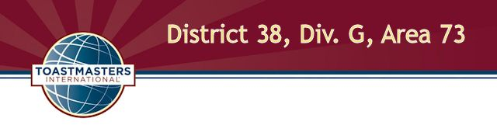
Humorous Speech and Table Topics Contest
Wednesday, September 9, 2015
5:30 P.M. at Horsham Township Library

Agenda

Contest Chair Title, Name, TM credentials
Chief Judge Name, TM credentials

5:30 Opening
Contest chair greets attendees and announces period for contestants to prepare and submit necessary paperwork.

6:00 Briefings
Contest chair briefs contestants and has them draw for speaking positions. Chief judge briefs judges, ballot counters and timers.

6:20 Call to order
Sergeant at arms calls the contest to order and introduces the contest chair.

6:21 Welcome
Contest chair welcomes contestants, functionaries, dignitaries and guests.

6:22 Humorous Speech Contest (5-7 min. per speaker, 1 min. between each speech)

Contestant name Speech title Order

List in alpha order title _____
List in alpha order title _____

6:50 Between-contest break (15 min.)

7:05 Call to order
Sergeant at arms reconvenes the contest and introduces the contest chair.

7:06 Table Topics Contest: (1-2 min. per speaker, 1 min. between each speech)

Contestant name Order

List in alpha order _____
List in alpha order _____

7:20 Contestant Interviews (15 min.)
Contest chair interviews contestants.

7:38 Contest Winner Announcements
Contest chair announces contest winners.

7:43 Closing
Contest chair shares closing comments. Division and district directors share comments and announcements.

7:48 Adjournment

The contest organizers would like to thank our corporate sponsors:

Acme Markets on Twining Road in Dresher, for providing the cheese/fruit tray.
Tony Roni's in Willow Grove for the tomato pies.


GO |  | G73!

